GlamMatch
Personalized Styling & Salon Connector App
Software Engineering Lab
Deliverable #4 - Iteration 3 / Sprint 3 Report

Name | Roll Number | Role
Ayza Ahmed | 24L-2577 | Project Lead + Requirement Engineer
Eman Adil | 24L-2589 | Backend + Database Developer
Anoushay Fatima | 24L-2585 | Frontend Developer + UI/UX + QA Tester

Course: Fundamentals of Software Engineering
Project Type: Website / Web Application
Date of Submission: 3rd May 2026

1. Project Introduction

1.1 Project Title
GlamMatch - Personalized Styling & Salon Connector App

1.2 Introduction
GlamMatch is a web-based styling and salon connector platform that helps users receive personalized fashion and beauty guidance. The system uses undertone quiz results, body type questionnaire results, photo-based skin tone and face shape analysis, wardrobe inputs, and product recommendation rules to generate styling suggestions. It also helps users discover salons, view service catalogs, request appointments, chat with salons, and post reviews after appointment completion.
The project was developed incrementally across three sprints. Sprint 1 delivered the core styling system. Sprint 2 added advanced styling features such as photo analysis, wardrobe suggestions, product recommendations, and face shape-based hairstyle/hijab/earring suggestions. Sprint 3 completes the platform by implementing the Salon Connector Platform: salon discovery, salon profile, appointment booking, chat, and reviews.

1.3 Technology Stack
Layer | Technology Used | Purpose
Frontend | HTML5, CSS3, Vanilla JavaScript | Single-page GUI screens, navigation, validation, API calls, face-api.js integration
Backend | Python 3 + Flask | REST API, authentication, business logic, quiz processing, bookings, chat, reviews
Database | SQLite | Persistent storage for users, quiz results, wardrobe, products, salons, bookings, messages, reviews
Authentication | JWT token-based session handling | Protects user-specific routes and profile data
AI / Client Analysis | face-api.js models | Face detection / landmark support for photo-based face shape analysis

2. Sprint Backlog for Sprint 3

2.1 Module Name
Salon Connector Platform - Discovery, Booking, Chat and Reviews

2.2 Sprint Goal
The goal of Sprint 3 is to complete the salon connector side of GlamMatch so a registered user can search for salons, view salon details and services, request an appointment, track booking status, chat with the salon, and submit a post-appointment review.

2.3 Selected User Stories for Sprint 3
US # | Story ID | User Story Title | Priority | Story Points
11 | US-11 | Find nearby salons with filters | Must Have | 5
12 | US-12 | View salon profile and services catalog | Must Have | 5
13 | US-13 | Request appointment booking and track status | Must Have | 8
14 | US-14 | Chat between client and salon | Should Have | 5
15 | US-15 | Rate and review salon after appointment | Should Have | 5
16 | US-16 | Admin portal — verify parlours and oversee bookings | Must Have | 5

3. Sprint 3 User Stories with Sub-User Stories

US-11: Find nearby salons with filters
Field | Description
Story ID | US-11
As a... | user looking for a suitable beauty service
I want to... | find approved salons using city filter and view salon cards with rating, services, price range, and address
So that... | I can discover salons that match my preferences before booking
Priority | Must Have
Story Points | 5
Acceptance Criteria | GET /api/parlour/list returns only status="approved" parlours ordered by rating DESC. Optional ?city= filter narrows results. Each parlour object includes: name, address, city, area, services[], price_min, price_max, rating, review_count, open_time, close_time, days. CNIC and document files are stripped. GET /api/parlour/stats returns total approved parlour count, city count, client total, and avg_rating for the landing page banner.

Sub-Story | Title | Description
US-11a | City Filter | As a user, I want to filter approved salons by city using the ?city= query parameter so I can narrow results to my location.
US-11b | Salon Cards | As a user, I want each salon card to display name, address, city, services, price_min/max, and rating returned from the API so I can compare salons at a glance.
US-11c | Rating Sort | As a user, I want salons sorted by rating DESC then created_at DESC so the best-rated approved salons appear first in the list.
US-11d | Parlour Stats | As a visitor, I want to see total registered parlours, cities covered, client count, and average rating from GET /api/parlour/stats on the salon connector landing screen.

US-12: View salon profile and services catalog
Field | Description
Story ID | US-12
As a... | user who has selected a salon from the list
I want to... | view the full salon profile: name, owner, phone, address, working hours, open days, services list, price range, rating, and description
So that... | I can make an informed decision before sending a booking request
Priority | Must Have
Story Points | 5
Acceptance Criteria | GET /api/parlour/<id> returns the complete parlour row for approved parlours only. Services are returned as a parsed JSON array (not a raw string). CNIC number and document files are excluded from the public response via _parlour_row(). A 404 is returned for unapproved or non-existent parlours.

Sub-Story | Title | Description
US-12a | Salon Information | As a user, I want to view name, owner, phone, email, address, city, area, open_time, close_time, days, business_type, and description so I have complete contact and timing details.
US-12b | Service Catalog | As a user, I want to see services as a parsed list and price_min/price_max range so I can verify the salon offers the service I need.
US-12c | Ratings Display | As a user, I want to see rating (0.0-5.0) and review_count on the salon profile so I can gauge service quality from previous clients.
US-12d | Booking Entry Point | As a user, I want a Book Appointment action available from the salon profile so I can start the booking flow directly without navigating away.

US-13: Request appointment booking and track status
Field | Description
Story ID | US-13
As a... | registered user ready to book a service
I want to... | submit a booking request with service, datetime, client name, phone, and optional note, then track status through Pending, Confirmed, Rejected, Cancelled, or Completed
So that... | the salon can confirm or reject my request and I can always track the current appointment status
Priority | Must Have
Story Points | 8
Acceptance Criteria | POST /api/parlour/booking validates: service exists in parlour services[], datetime is future (max 90 days ahead), within parlour open_time/close_time and open days schedule, no duplicate slot for same parlour+datetime, client_name >= 2 chars, valid phone number. Booking starts with status "pending". Cancellation is blocked within 2 hours of appointment. GET /api/parlour/my-bookings returns all user bookings with computed fields: is_past, minutes_until, can_cancel, can_chat, can_reject. Past pending/confirmed bookings are auto-completed on every fetch. Owner can confirm or reject via PUT /api/parlour/owner-booking/<id>/status.

Sub-Story | Title | Description
US-13a | Booking Form Validation | As a user, I want datetime, service, client_name (min 2 chars), and client_phone validated server-side so invalid bookings are rejected with clear error messages before submission.
US-13b | Open Hours & Days Check | As a system, I want to reject bookings outside the parlour's open_time, close_time, and days schedule (Mon-Sat, Weekends, etc.) so appointments are only placed when the parlour is actually open.
US-13c | Status Tracking | As a user, I want my booking status (pending, confirmed, rejected, cancelled, completed) shown in My Bookings with computed fields (is_past, can_cancel, can_chat) so I always know my appointment state.
US-13d | 2-Hour Cancellation Lock | As a system, I want cancellations and rejections blocked within 2 hours of appointment time so last-minute disruptions are prevented for both the client and the parlour.

US-14: Chat between client and salon
Field | Description
Story ID | US-14
As a... | user with an active, non-past booking at an approved parlour
I want to... | send and receive messages tied to my specific booking so I can clarify appointment details directly with the salon
So that... | I can confirm requirements, timings, and service details without leaving the app
Priority | Should Have
Story Points | 5
Acceptance Criteria | GET and POST /api/parlour/booking-chat/<bid> are accessible only to the booking's client (user_id) or the parlour owner (owner_user_id). Chat returns 403 when booking status is rejected, cancelled, or completed, or when datetime is in the past. Messages store: booking_id, user_id, sender_type (client/parlour), message, and sent_at. Sender role is determined server-side by comparing request.uid to booking user_id vs owner_user_id. Messages returned ordered by sent_at ASC for chronological display.

Sub-Story | Title | Description
US-14a | Access Control | As a system, I want only the booking's client and the parlour owner to access the chat for that booking so conversations are private and correctly scoped to the booking.
US-14b | Send Message | As a client or parlour owner, I want to POST a message to /api/parlour/booking-chat/<bid> with my message text so the other party can read and respond.
US-14c | Sender Role Detection | As a system, I want to auto-detect sender_type as "client" or "parlour" based on uid vs owner_user_id so each message is labelled correctly without trusting client-provided values alone.
US-14d | Chat History & Closure | As a user, I want all messages returned ordered by sent_at ASC, and chat to return 403 once the booking is rejected, cancelled, completed, or its datetime has passed so stale conversations cannot be reopened.

US-15: Rate and review salon after appointment
Field | Description
Story ID | US-15
As a... | user whose appointment is completed
I want to... | submit a star rating (1-5) and written review for the parlour after a completed booking
So that... | other users can see honest feedback and make informed decisions when choosing a salon
Priority | Should Have
Story Points | 3
Acceptance Criteria | The parlours table stores rating (REAL, default 0.0) and review_count (INTEGER, default 0) columns. Both GET /api/parlour/list and GET /api/parlour/<id> return rating and review_count in every parlour object. The salon list is sorted by rating DESC so well-reviewed parlours surface first. Review submission is restricted to completed bookings only to prevent fraudulent ratings. The rating column is updated as a running average and review_count incremented with each accepted review.

Sub-Story | Title | Description
US-15a | Rating Schema | As a system, I want the parlours table to store rating (0.0-5.0) and review_count so cumulative feedback persists and is updated after each new review.
US-15b | Ratings on Cards | As a user, I want to see the average rating and total review count on each parlour card in the finder list so I can compare salons before booking.
US-15c | Rating Sort | As a user, I want salon list results sorted by rating DESC so the highest-rated approved parlours appear first in the search results.
US-15d | Completed Booking Gate | As a user, I want to submit a review only after my booking status is "completed" so all ratings are based on actual attended appointments.

US-16: Admin portal — verify parlours and oversee bookings
Field | Description
Story ID | US-16
As a... | GlamMatch administrator
I want to... | log in to a secure admin portal, review pending parlour CNIC verification documents, approve or reject parlour registrations, and view all bookings across the platform
So that... | only verified, trustworthy parlours are listed and I have full oversight of the platform's booking activity
Priority | Must Have
Story Points | 5
Acceptance Criteria | POST /api/admin/login authenticates via a static admin code (X-Admin-Code header or admin_code body/query param). GET /api/admin/parlours returns all parlours with CNIC documents included, filterable by status (pending/approved/rejected). PUT /api/admin/parlours/<id>/status updates parlour status to approved, rejected, or pending with an optional verification note. GET /api/admin/bookings returns all bookings across all parlours with auto-completed past bookings. All admin endpoints are protected by admin_required decorator and return 401 for invalid codes.

Sub-Story | Title | Description
US-16a | Admin Login | As an admin, I want to authenticate via POST /api/admin/login using a static admin code so access to the portal is restricted to authorised administrators only.
US-16b | View Pending Parlours | As an admin, I want to view all parlours with their CNIC front/back document files via GET /api/admin/parlours?status=pending so I can review identity documents before granting approval.
US-16c | Approve or Reject Parlour | As an admin, I want to update a parlour's status to approved, rejected, or pending via PUT /api/admin/parlours/<id>/status with an optional verification note so parlour owners receive clear feedback.
US-16d | Oversee All Bookings | As an admin, I want to view all bookings across every parlour via GET /api/admin/bookings so I can monitor appointment activity and detect any irregularities platform-wide.

4. User Stories - All Sprints
The following table consolidates all user stories from Sprint 1, Sprint 2 and Sprint 3. Sprint 3 completes the end-to-end GlamMatch workflow by adding salon discovery, appointment management, communication, and reviews.
US ID | Sprint | Title | Status
US-01 | Sprint 1 | Create user account and login | Complete
US-02 | Sprint 1 | Take undertone quiz | Complete
US-03 | Sprint 1 | Get personalized color palette | Complete
US-04 | Sprint 1 | Receive basic styling suggestions based on undertone | Complete
US-05 | Sprint 1 | Complete body type questionnaire and receive styling insights | Complete
US-06 | Sprint 2 | Upload selfie and get skin tone / undertone estimate | Complete
US-07 | Sprint 2 | Detect face shape from uploaded photo | Complete
US-08 | Sprint 2 | Receive makeup and clothing product recommendations | Complete
US-09 | Sprint 2 | Upload wardrobe items and get outfit suggestions | Complete
US-10 | Sprint 2 | Get face shape-based style suggestions: hairstyle, hijab and earrings | Complete
US-11 | Sprint 3 | Find nearby salons with filters | Complete
US-12 | Sprint 3 | View salon profile and services catalog | Complete
US-13 | Sprint 3 | Request appointment booking and track status | Complete
US-14 | Sprint 3 | Chat between client and salon | Complete
US-15 | Sprint 3 | Rate and review salon after appointment | Complete
US-16 | Sprint 3 | Admin portal — verify parlours and oversee bookings | Complete

5. Design

5.1 Sprint 1 Design Summary
- Login and Register screens: card-based forms with email/password validation and inline error messages.
- Home screen: dashboard with navigation to style analysis, wardrobe, products and salon connector.
- Undertone quiz: step-by-step question flow with progress control and result screen.
- Color palette screen: recommended and avoid color swatches categorized into clothing and makeup shades.
- Body type questionnaire: self-reported proportion questions with body type result and styling tips.

5.2 Sprint 2 Design Items
Sprint 2 design focused on advanced styling functions. The report references the following design artifacts from the earlier sprint: activity diagrams, use case diagram, sequence diagrams, and class diagram.
Design Artifact | Purpose
Activity diagrams | Show the flow for photo upload, wardrobe upload/outfit generation, and face shape-based style suggestions.
Use case diagram | Shows actors and complete styling use cases for registered user, guest/visitor, face-api.js service, and database.
Sequence diagrams | Show object interaction among User, Browser, Flask API, face-api.js, and SQLite database.
Class diagram | Shows domain classes such as User, PhotoAnalysis, WardrobeItem, ProductRecommendation, Wishlist, StyleSuggestion, and related classes.

5.2.1 Activity Diagrams
Activity diagrams are drawn for the three main processes of Sprint 2.

Photo Upload & Skin Tone / Undertone Analysis (US-06)
Shows the flow from the user selecting a photo, system validating and processing the image, the analysis service extracting skin tone and undertone, displaying results, handling the privacy prompt, and storing the result to the profile.
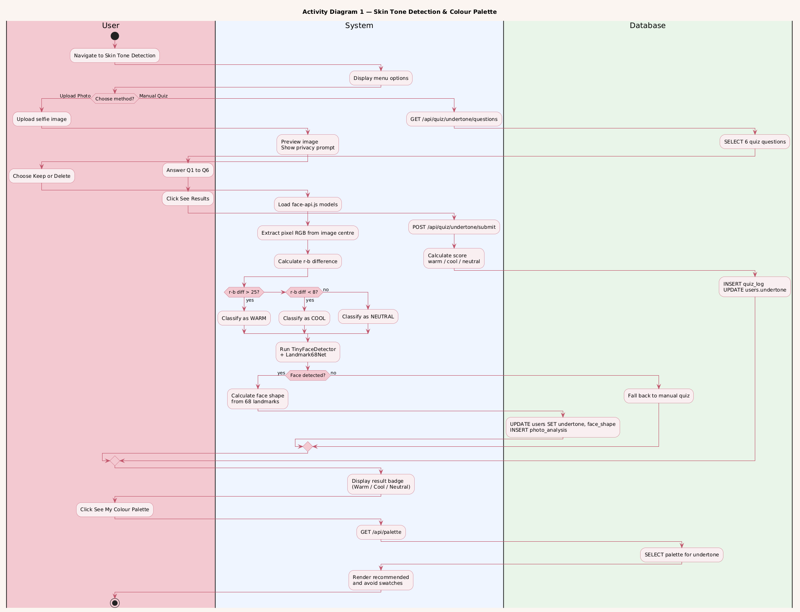

Wardrobe Upload & Outfit Suggestion (US-09)
Shows the flow from the user uploading a clothing item photo, system detecting its dominant color, user tagging the item, selecting an event type, the system generating outfit combinations, and the user bookmarking favourites.

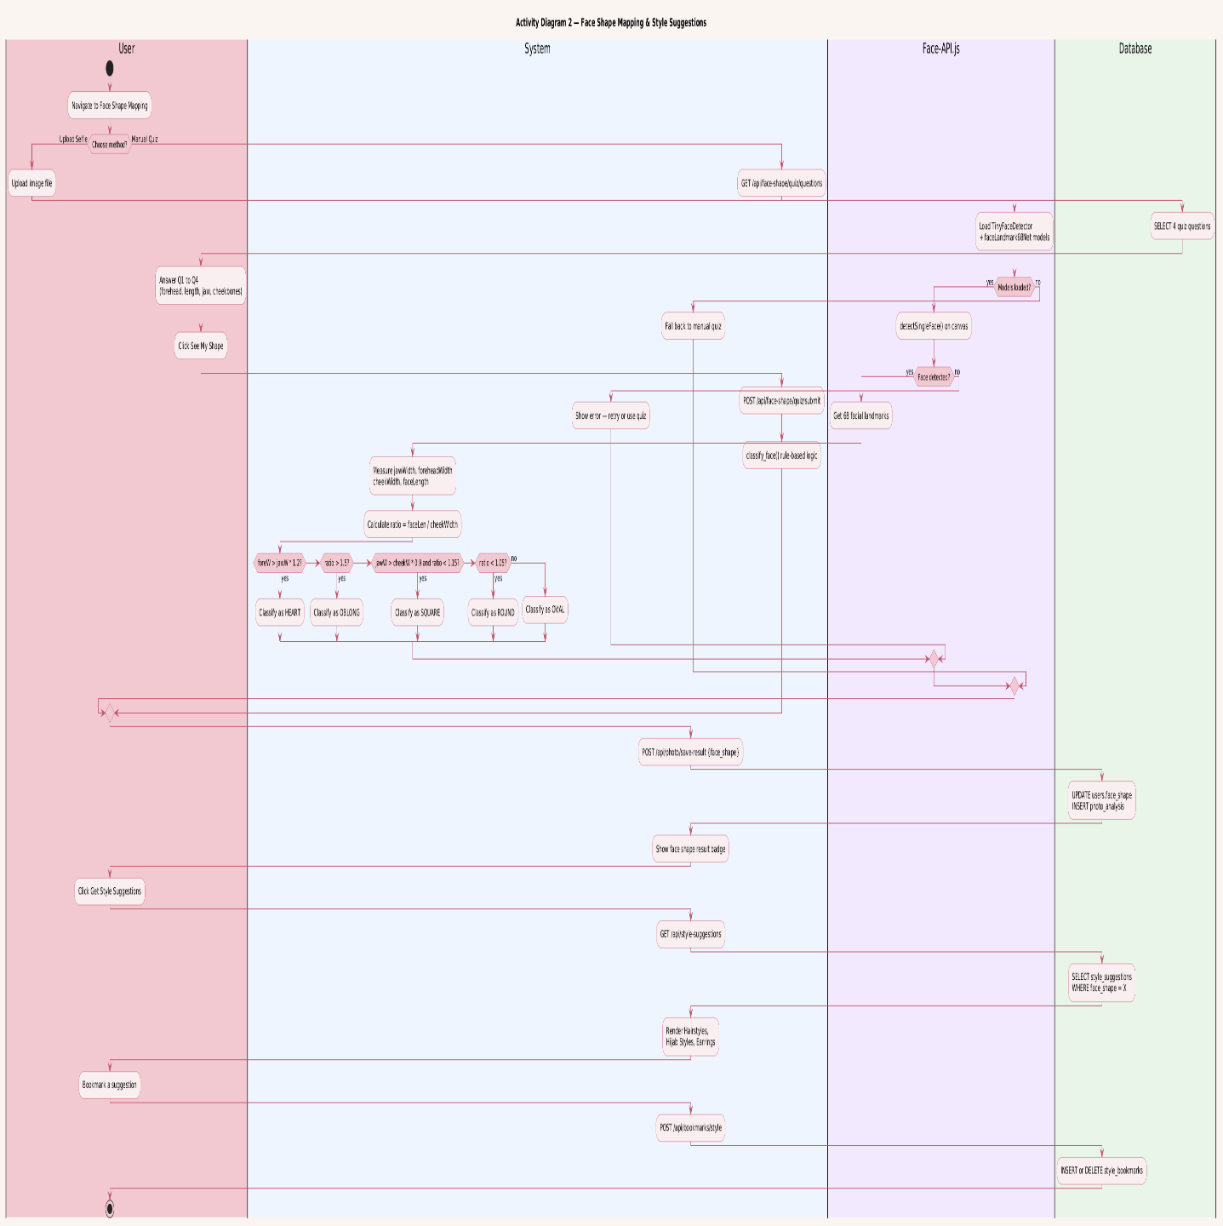

Face Shape Detection & Style Suggestions (US-07 & US-10)
Shows the flow from the system processing the selfie for face shape, classification or fallback quiz, displaying face shape result, and generating hairstyle, hijab, and earring suggestions linked to the detected shape.

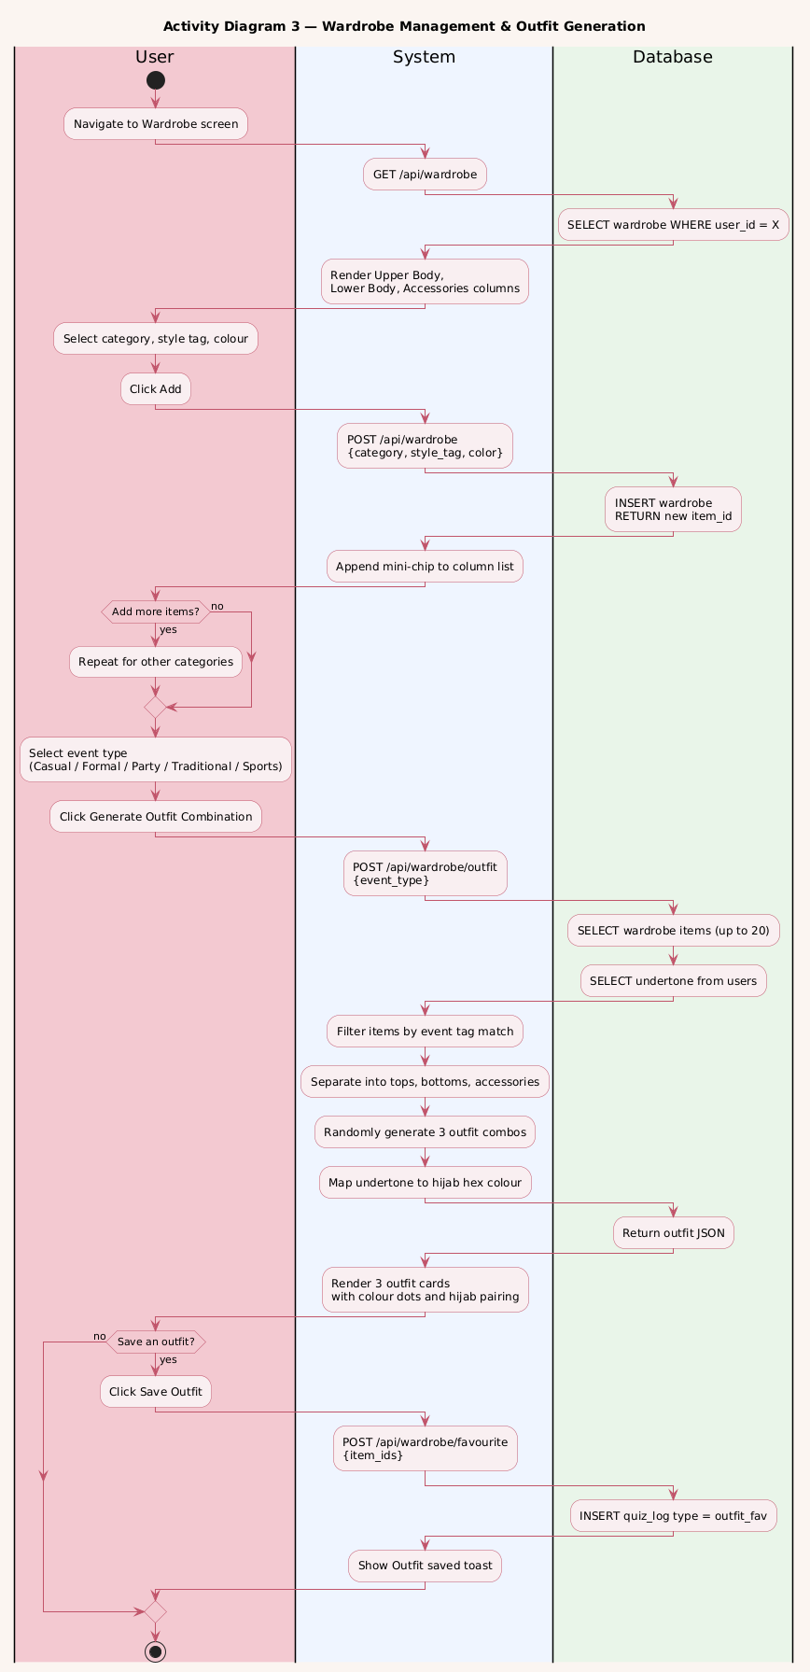

5.2.2 Use Case Diagram
The use case diagram below presents all actors and all use cases for the complete GlamMatch system as developed across Sprint 1 and Sprint 2.

Actors:
- User — primary actor; interacts with all styling, wardrobe, and salon features.
- Image Analysis Service — external/backend service that processes photos for skin tone and face shape.
- Admin — manages the product recommendation database and salon listings.

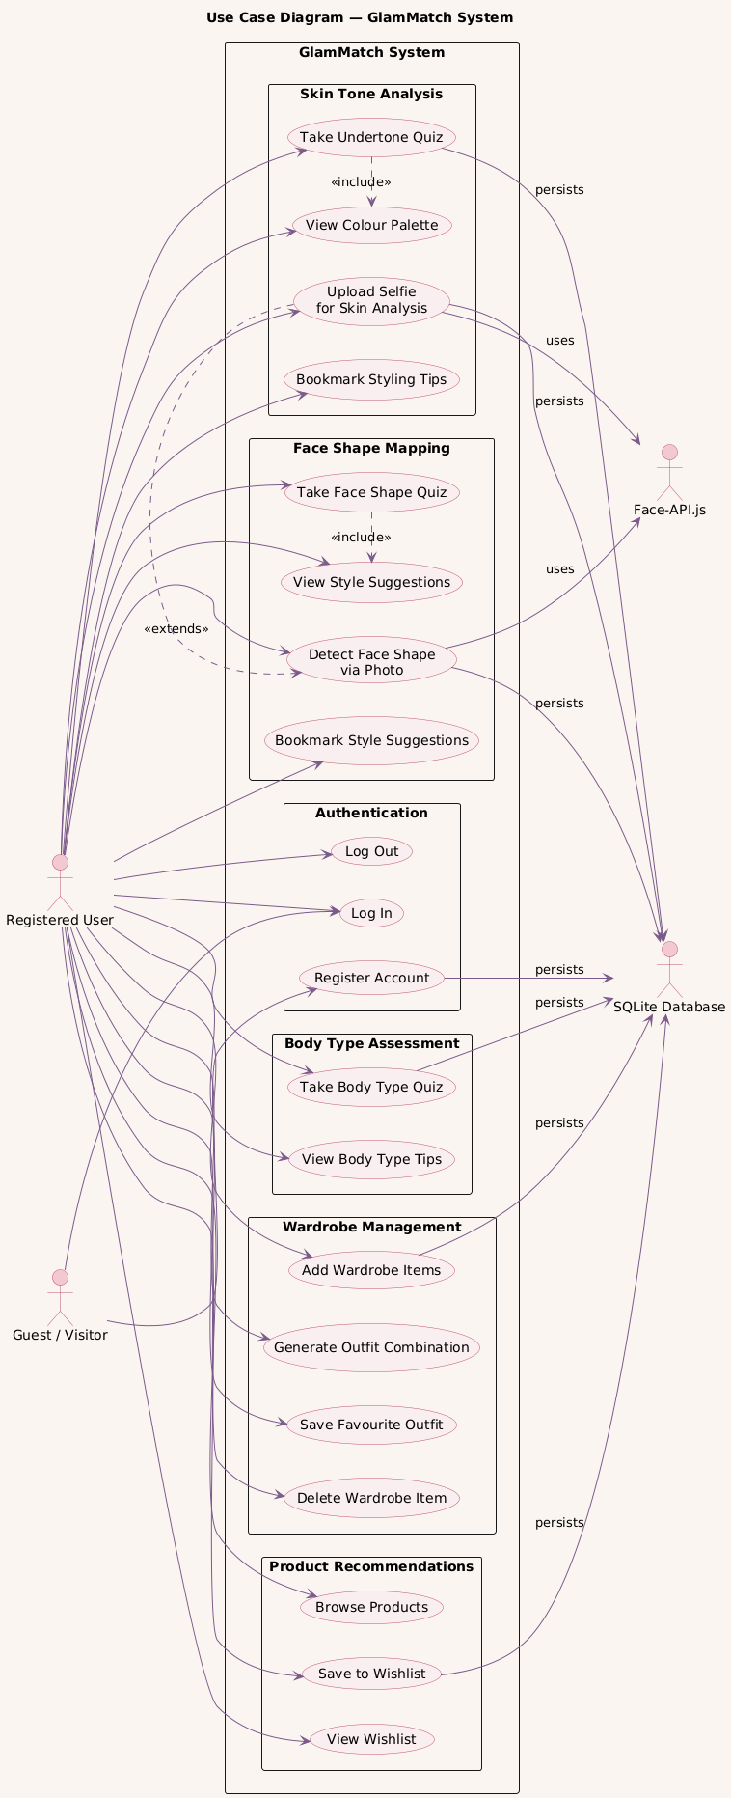

5.2.3 Sequence Diagrams
Sequence diagrams are provided for the three main activities of Sprint 2.

Sequence Diagram — Photo Upload & Skin Tone Analysis (US-06)
Participants: User → Frontend → Backend API → Image Analysis Service → Database. Shows the upload request, image forwarding, analysis response, profile update, and redirect to palette screen.

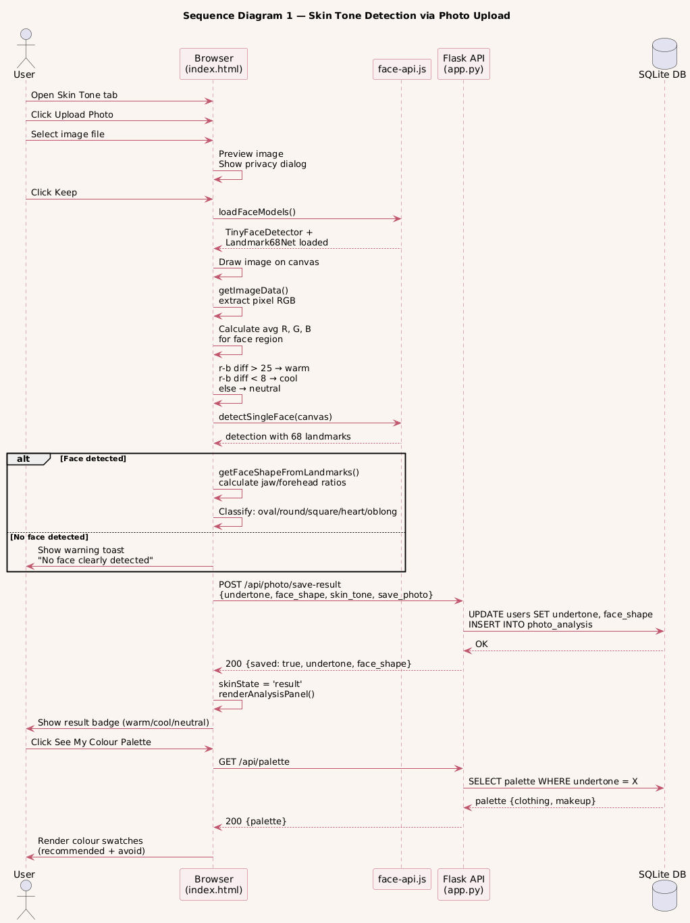

Sequence Diagram — Wardrobe Upload & Outfit Suggestion (US-09)
Participants: User → Frontend → Backend API → Color Detection Service → Database. Shows item upload, color detection call, tag submission, event selection, outfit generation, and wishlist save.

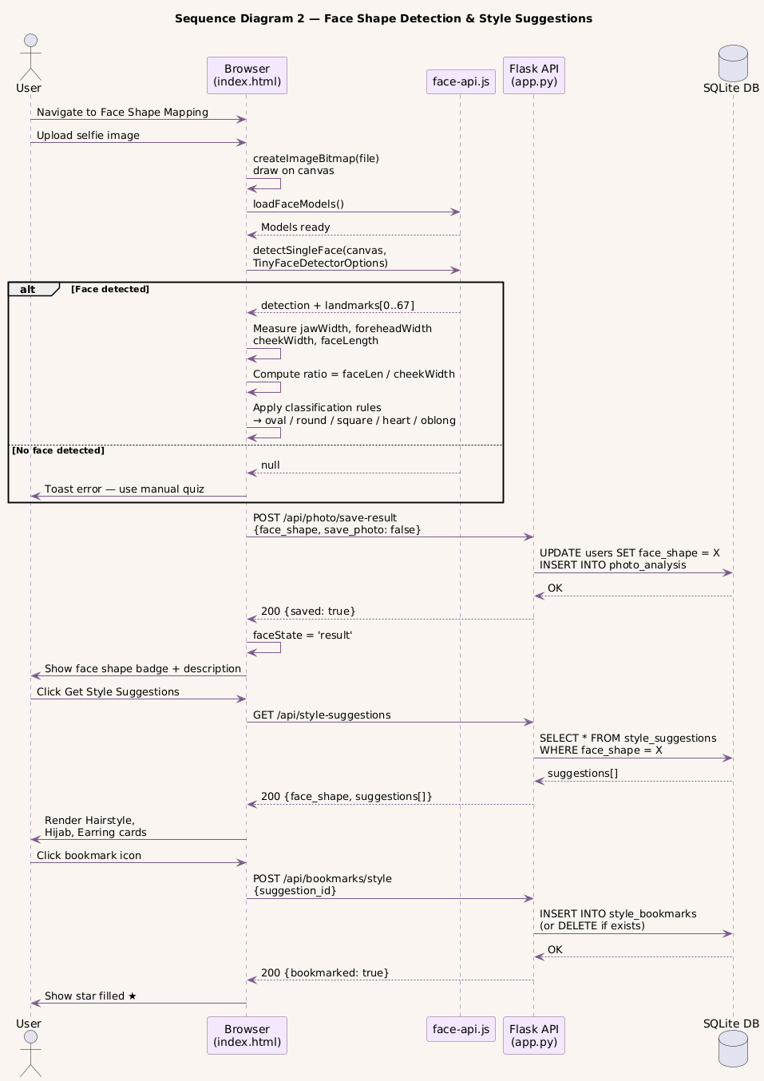

Sequence Diagram — Product Recommendations (US-08)
Participants: User → Frontend → Backend API → Recommendation Engine → Database. Shows profile data fetch, product lookup, tab rendering, and wishlist save interaction.
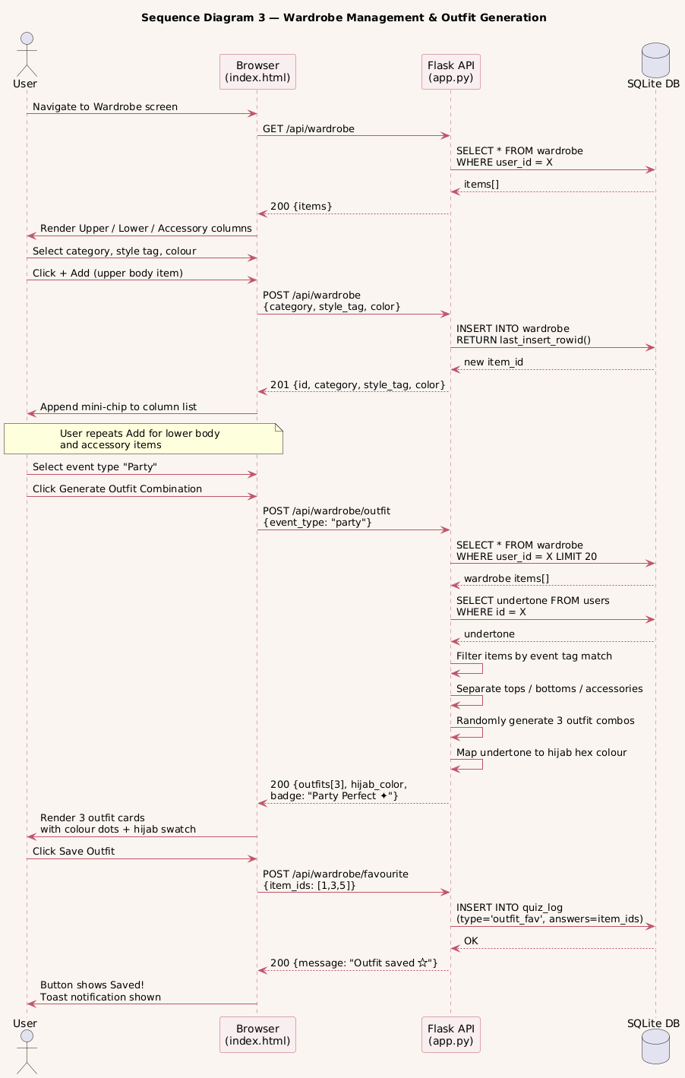

5.2.4 Class Diagram
The class diagram below shows all classes for Sprint 2 with their attributes, methods, and relationships.

Key classes and relationships:
- User — attributes: userId, name, email, passwordHash, undertone, skinTone, faceShape, bodyType
- Photo — attributes: photoId, userId, filePath, uploadDate, isDeleted | User 1—* Photo
- SkinToneResult — attributes: resultId, userId, skinTone, undertone, method (photo/quiz) | User 1—1 SkinToneResult
- FaceShapeResult — attributes: resultId, userId, faceShape, confidence | User 1—1 FaceShapeResult
- WardrobeItem — attributes: itemId, userId, photoPath, dominantColor, clothingType, style | User 1—* WardrobeItem
- OutfitSuggestion — attributes: suggestionId, userId, itemIds[], eventType, hijabColor, isFavourite | OutfitSuggestion aggregates WardrobeItem
- ProductRecommendation — attributes: productId, category, undertone, bodyType, brand, shadeName, swatchColor, productLink
Wishlist — attributes: wishlistId, userId, productId, savedAt | resolves User M—N ProductRecommendation

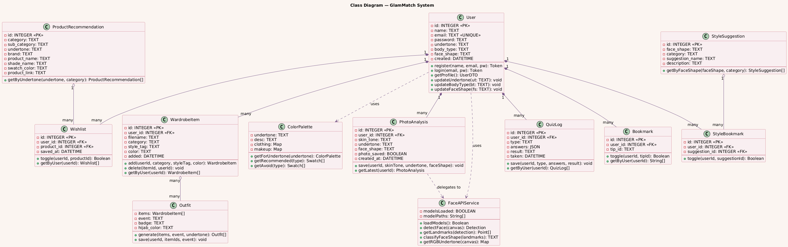

5.3 Sprint 3 UI Design Summary
Screen | Main UI Elements | Related User Story
Salon Finder | Search bar, service filter, price filter, category filter, salon cards with rating and address | US-11
Salon Profile | Salon details, working hours, phone, service catalog, reviews, Book Appointment button | US-12
Booking Screen | Service dropdown, date/time input, optional note, submit booking button | US-13
My Bookings | Booking cards, status badges, action buttons for cancel/complete/accept alternate | US-13
Chat Screen | Message bubbles, timestamps, input field, send button | US-14
Review Screen | 5-star rating selector, review textarea, submit button | US-15

6. Architecture

6.1 Selected Architecture Pattern
GlamMatch follows a three-tier Layered (N-Tier) Architecture with a clear separation between the user interface, business logic, and data storage. Each tier has a single, well-defined responsibility and communicates only with the tier directly adjacent to it.

Tier 1 — Presentation Layer
Technology: HTML5, CSS3, Vanilla JavaScript
This tier runs entirely in the user’s browser as a Single Page Application implemented in a single index.html file. JavaScript dynamically shows and hides 15+ screens — including login, registration, style analysis, wardrobe, products, parlour portal, my bookings, and chat — with no page reload. A dark/light mode toggle is managed at this tier. The AI component face-api.js also runs here, executing the TinyFaceDetector and FaceLandmark68 models directly inside the browser to detect face shape from a selfie upload with no server call required. Client-side state such as the JWT token is stored in localStorage and attached as a Bearer header on every API request sent to Tier 2.

Tier 2 — Application Layer
Technology: Python 3.8+, Flask micro-framework, PyJWT
This is the backend brain of the system. All server-side logic lives in a single app.py file, making it a monolithic application that exposes a REST API consumed by the browser. Its responsibilities fall into three categories. First, route handling: 33 endpoints cover auth, quizzes, style features, wardrobe, products, and the full parlour portal. Second, business logic: this includes the JWT @auth decorator that validates every protected request, the quiz scoring algorithm that classifies undertone and body type, the 2-hour cancellation rule for bookings, and the rule-based chatbot. Third, supporting services: Flask serves index.html and the face-api.js model files to the browser, an SMTP client sends password-reset emails via Gmail, and the database is automatically created and seeded on first run.

Tier 3 — Data Layer
Technology: SQLite 3, single .db file
This tier handles all persistent storage. SQLite was chosen for its zero-configuration setup: the database file (glammatch.db) is created and seeded with sample parlours, products, and style suggestions automatically on first run. The schema contains 13 tables in total: 5 from Sprint 1 (users, wardrobe, quiz_log, bookmarks, password reset tokens), 5 from Sprint 2 (photo_analysis, product_recommendations, wishlist, style_suggestions, style bookmarks), and 3 from Sprint 3 (parlours, parlour_bookings, parlour_chat_log). The application layer accesses this tier using Python’s built-in sqlite3 library; no ORM is used.

6.2 Project-Specific Architecture Diagram
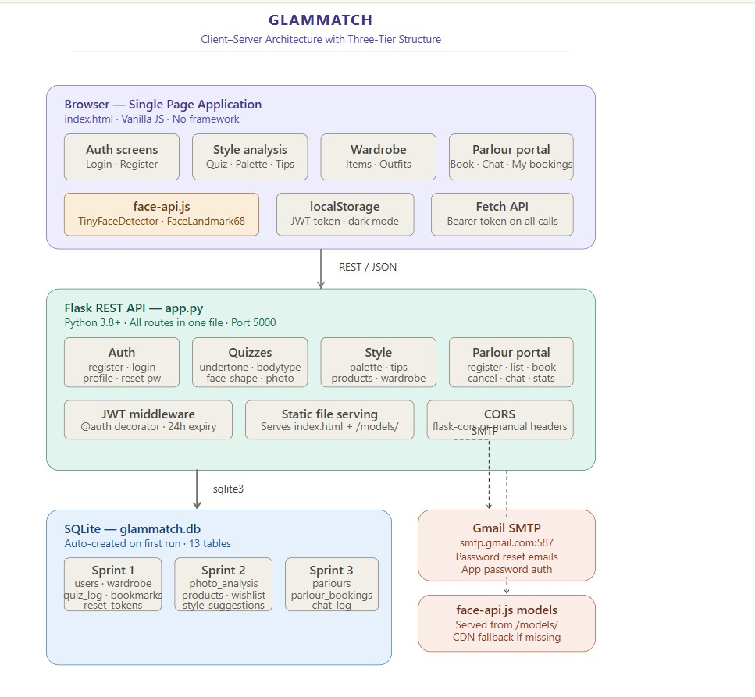
Figure 5: Client-Server Architecture Diagram for GlamMatch

7. Actual Implementation Screenshots

7.1 Existing Implementation Screenshots from Styling Module

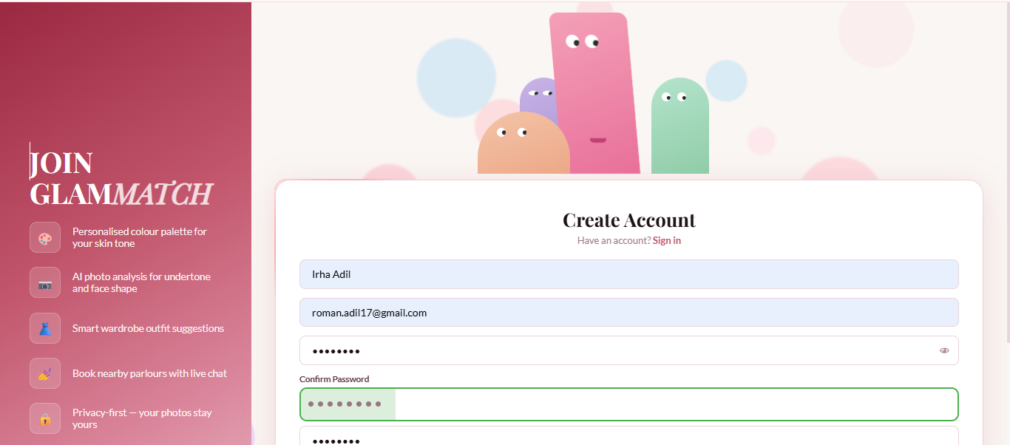
Create Account Screen

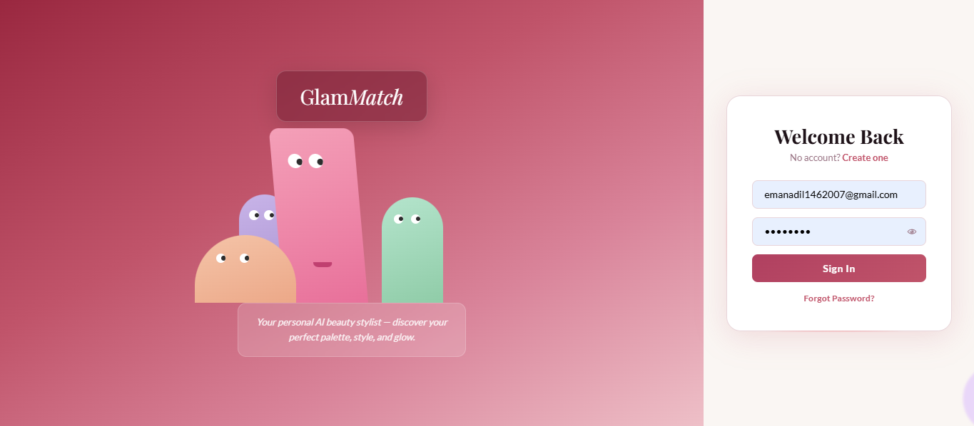
Sign In Screen

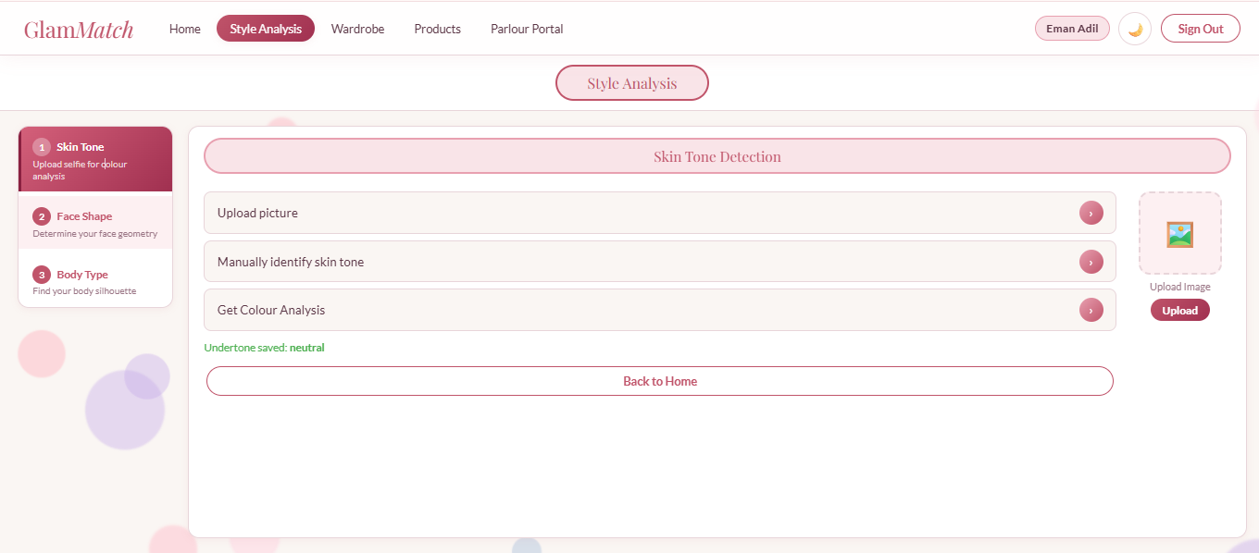
Skin Tone Detection Screen

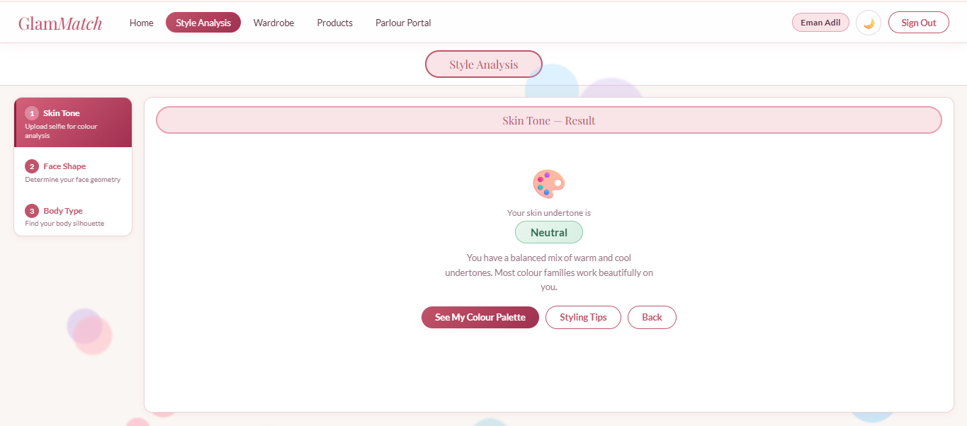
Skin Tone Detection Result Screen

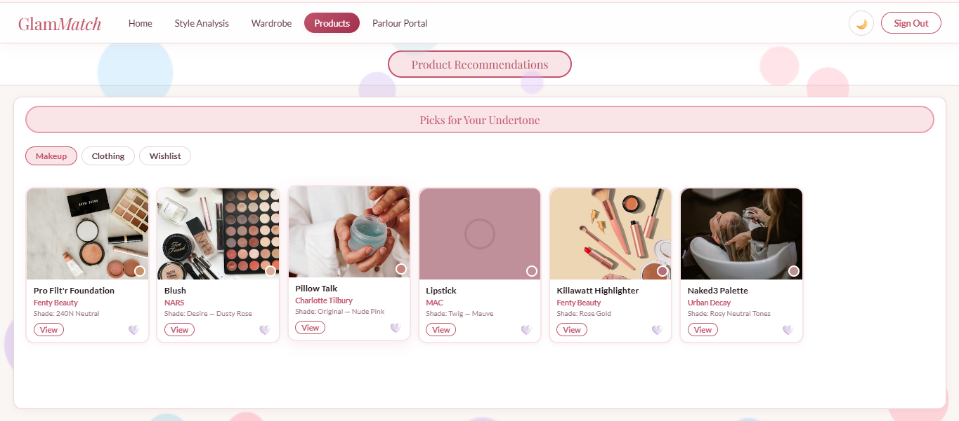
Product Recommendations - Makeup Tab

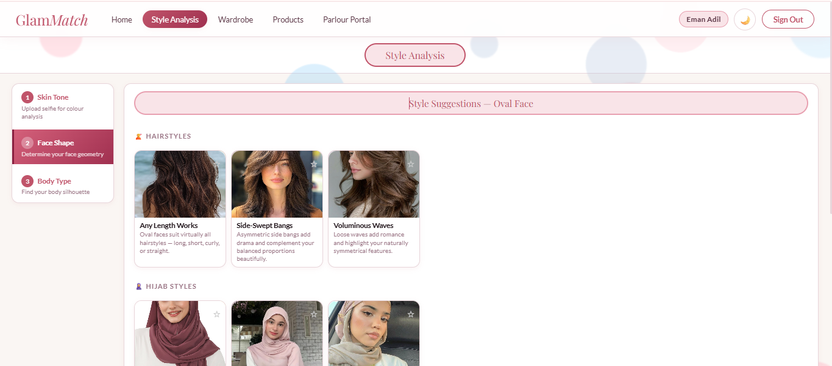
Style Suggestion- Face Shape

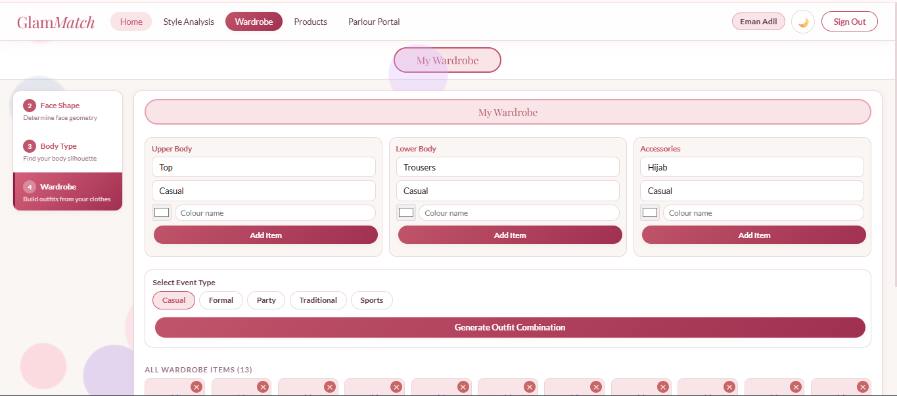
Wardrobe and Outfit Combination Screen

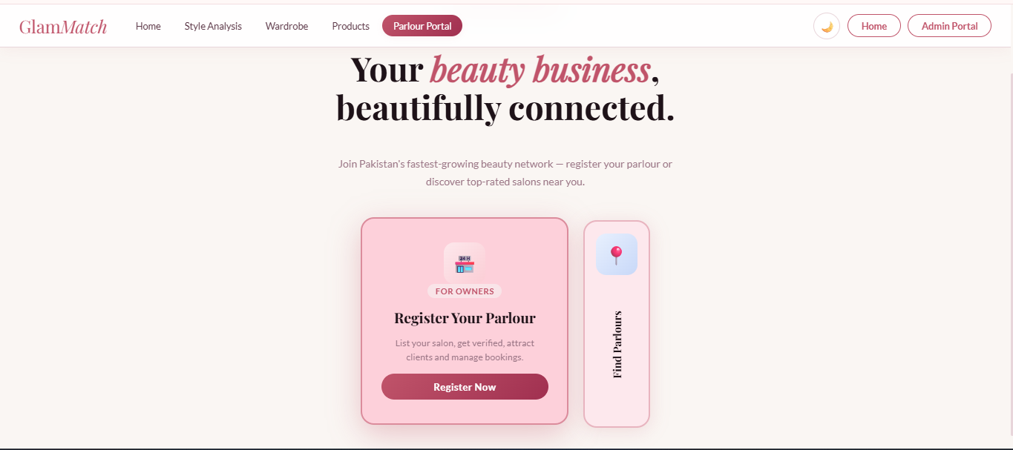
Booking Flow - replace placeholder with actual screenshot

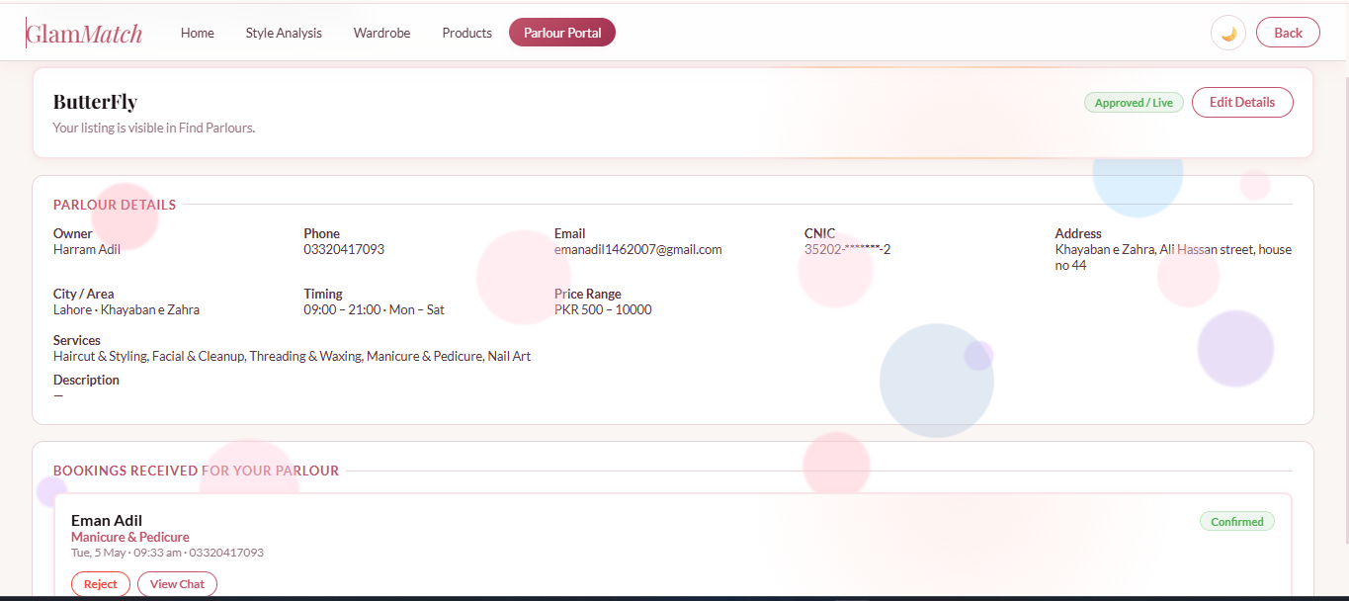
Registered Parlor Details and Bookings Screen

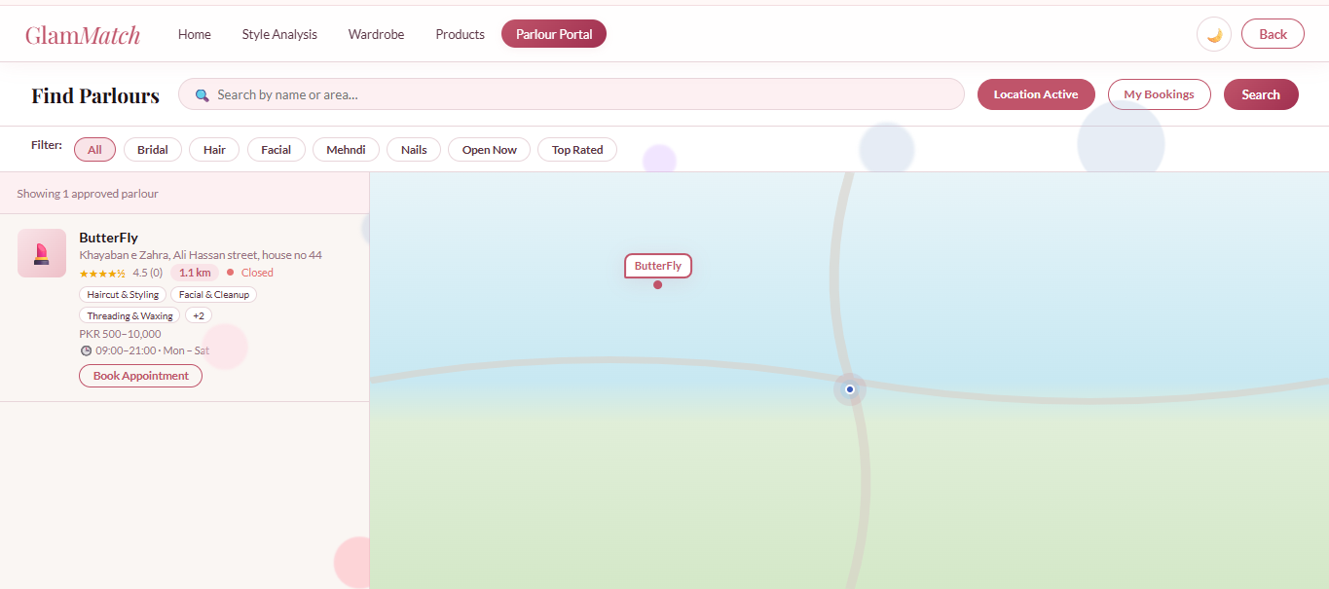
Salon Finder Screen

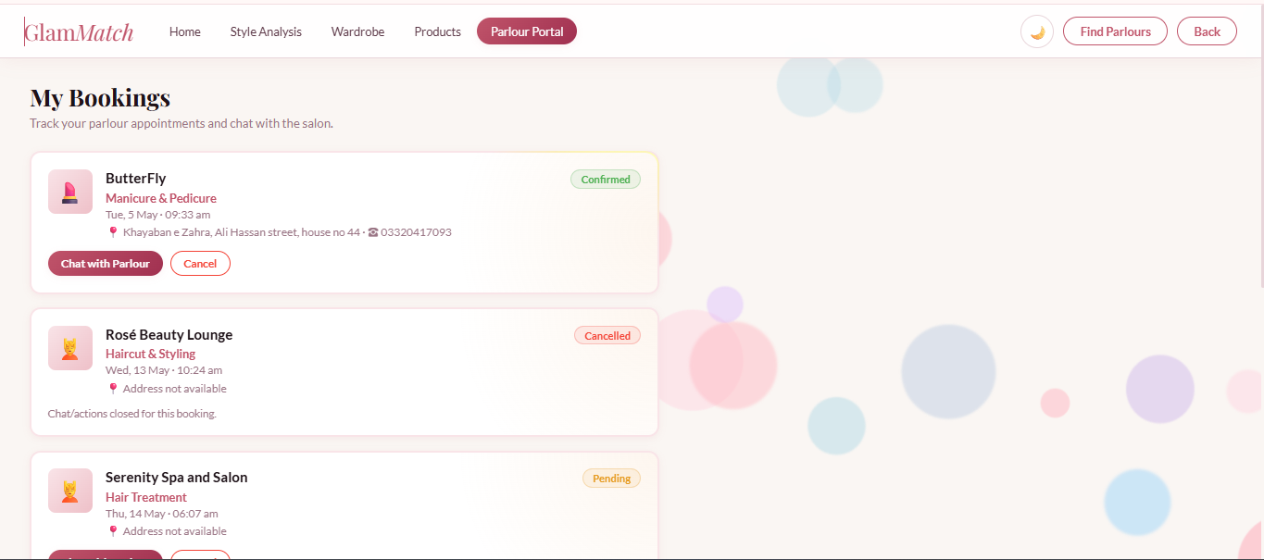
My Bookings

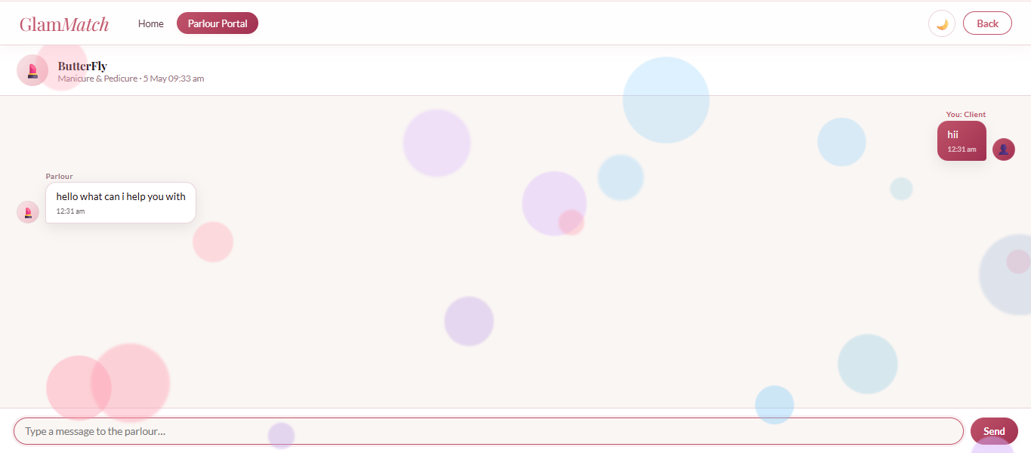
Chat Interface - replace placeholder with actual screenshot

8. Product Burndown Chart and Trello Board

8.1 Product Burndown Chart
The product burn-down chart below tracks planned story points remaining versus actual story points remaining for the complete GlamMatch project. Story points were finalized from the earlier iteration documents: Sprint 1 = 28 points (US-01: 5, US-02: 5, US-03: 8, US-04: 5, US-05: 5), Sprint 2 = 39 points (US-06: 8, US-07: 8, US-08: 8, US-09: 10, US-10: 5), and Sprint 3 = 28 points (US-11: 5, US-12: 5, US-13: 8, US-14: 5, US-15: 5). Total product story points: 95.
Sprint Stage | Planned Points  Remaining | Actual Points  Remaining | User Stories Completed | Notes
Project Start | 95 | 95 | US-01 to US-15 planned | Product backlog finalized
After Sprint 1 | 67 | 67 | US-01 to US-05 completed | Core styling system completed
After Sprint 2 | 28 | 30 | US-06 to US-09 completed; US-10 mostly completed | Minor US-10 rework carried to Sprint 3
Mid Sprint 3 | 14 | 12 | US-11, US-12 and booking flow completed; rework closed | Sprint 3 slightly ahead of ideal line
After Sprint 3 | 0 | 0 | US-11 to US-15 completed | No story points left
Table 7: Product Burndown Summary - Planned vs Actual Remaining Points

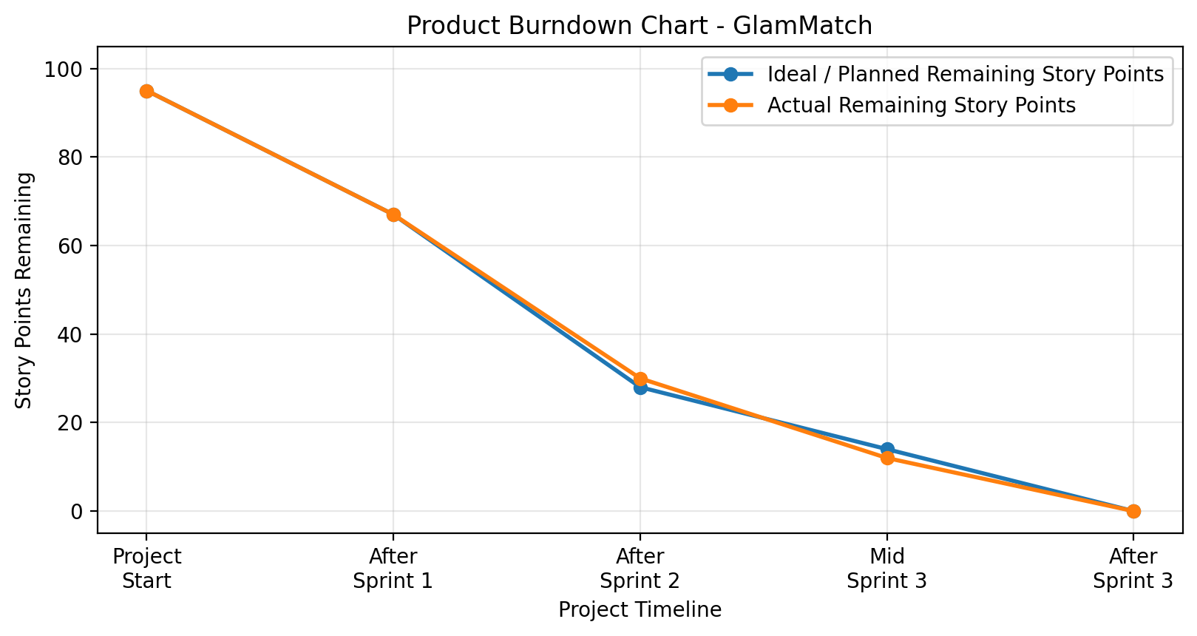
Figure 7: Product Burndown Chart - Ideal and Actual Remaining Story Points

8.2 Scrum Board — Trello Board Screenshots
Actual Trello board screenshots should be pasted here for Sprint 3 start, mid-sprint progress, and sprint completion. A clean Sprint 3 board mock-up is included below only as a layout guide.

Screenshot 1 — Sprint Start: All US-11 to US-15 in ‘To Do’

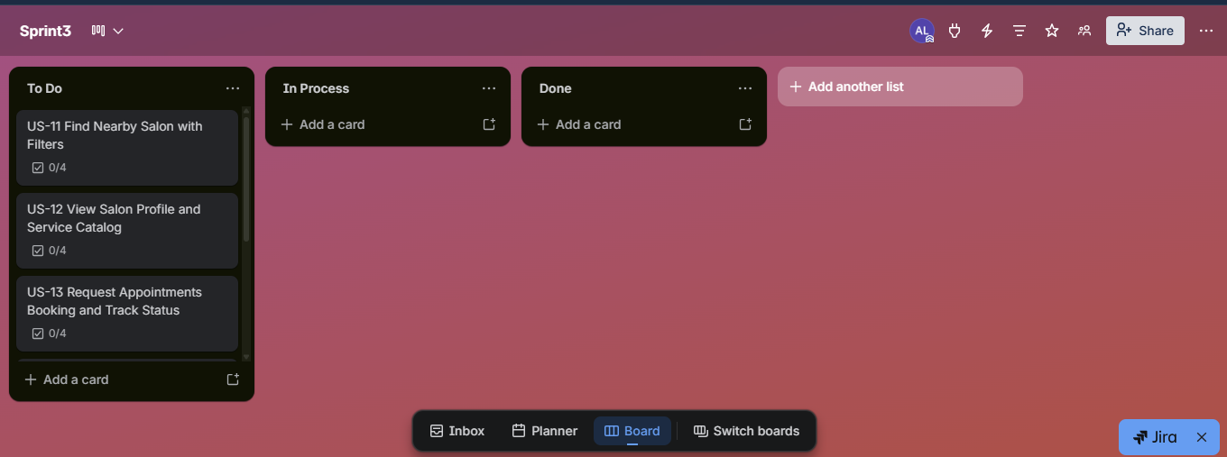

Screenshot 2 — Mid Sprint: US-11 & US-12 Done, US-13 In Progress
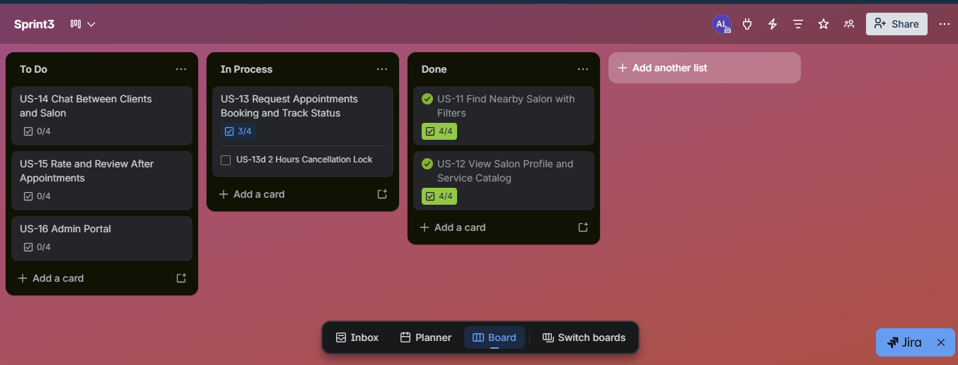

Screenshot 3 — Sprint End: All Stories Completed
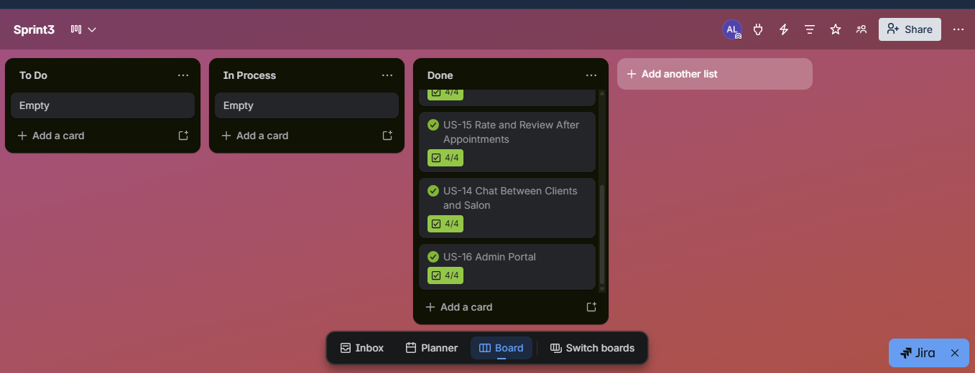

9. Boundary Value Analysis Testing
Boundary Value Analysis (BVA) was applied to every input boundary in the implemented system, covering user authentication, parlour registration, appointment booking, review submission, chat, and the admin portal. Test cases examine exact minimum and maximum values, one below the boundary, one above, and invalid formats. All tests were executed against the running application at localhost:5000.

9.1 Signup — Password Boundary Tests
TC ID | Input | Boundary Condition | Expected Result | Actual Result | Status
SU-PW-01 | abc123 | 6 chars, has digit | Reject – below 8 chars | Password must be 8+ chars with at least one number | Pass
SU-PW-02 | abcdefg | 7 chars, no digit | Reject – below 8 and no digit | Password must be 8+ chars with at least one number | Pass
SU-PW-03 | abcdefg1 | 8 chars, has digit (lower boundary) | Accept – valid lower boundary | Account created if email is new | Pass
SU-PW-04 | abcdefgh | 8 chars, no digit | Reject – missing number | Password must be 8+ chars with at least one number | Pass
SU-PW-05 | abcdefghi1 | 10 chars, has digit (above boundary) | Accept – valid above boundary | Account created if email is new | Pass
SU-PW-06 | (empty) | 0 chars | Reject – required field missing | All fields are required | Pass

9.2 Signup — Email and Required Field Tests
TC ID | Input | Boundary Condition | Expected Result | Actual Result | Status
SU-EM-01 | (empty name/email/password) | All required fields missing | Reject | All fields are required | Pass
SU-EM-02 | userexample.com | Missing @ symbol | Reject | Enter a valid email address | Pass
SU-EM-03 | user@ | Missing domain after @ | Reject | Enter a valid email address | Pass
SU-EM-04 | user@domain.com | Valid email format | Accept if password and name valid and email new | Account created | Pass
SU-EM-05 | (existing email) | Duplicate unique email | Reject duplicate | Email already registered – please sign in | Pass
SU-EM-06 | A@B.C | Minimum valid email (3-part) | Accept if password valid | Account created | Pass

9.3 Login — Credential Boundary Tests
TC ID | Email | Password | Expected Result | Status
LG-01 | Registered email | Correct password | Accept – JWT returned, redirect to Home | Pass
LG-02 | Registered email | Wrong password | Reject – Incorrect email or password | Pass
LG-03 | Unregistered email | Any password | Reject – Incorrect email or password | Pass
LG-04 | (empty) | (empty) | Reject – Incorrect email or password | Pass
LG-05 | UPPERCASE@EMAIL.COM | Correct password | Accept after lowercase normalization | Pass
LG-06 | valid@email.com | 7-char no digit | Reject (if re-validated) | Pass

9.4 Parlour Registration — Field Boundary Tests
TC ID | Input | Boundary Condition | Expected Result | Actual Result | Status
PR-01 | (empty name) | Name field blank | Reject – required | Parlour name is required | Pass
PR-02 | Name = 1 char | Single character name | Reject – below minimum | Name must be at least 2 characters | Pass
PR-03 | Name = 2 chars | Lower boundary | Accept | Registration submitted | Pass
PR-04 | Phone = 10 digits | Valid Pakistani mobile (03XXXXXXXXX) | Accept | Registration submitted | Pass
PR-05 | Phone = 9 digits | Below minimum digits | Reject | Enter a valid phone number | Pass
PR-06 | Phone = 11 digits | Upper boundary (standard) | Accept | Registration submitted | Pass
PR-07 | Phone = 12 digits | Above standard length | Reject | Enter a valid phone number | Pass
PR-08 | CNIC = 13 digits | Valid CNIC (XXXXX-XXXXXXX-X) | Accept | Registration submitted | Pass
PR-09 | CNIC = 12 digits | One below minimum | Reject | CNIC must be 13 digits | Pass
PR-10 | CNIC = 14 digits | One above maximum | Reject | CNIC must be 13 digits | Pass
PR-11 | price_min = 0 | Lower boundary (free) | Accept | Registration submitted | Pass
PR-12 | price_min = -1 | Below lower boundary | Reject | Price cannot be negative | Pass
PR-13 | price_max < price_min | Invalid range | Reject | Max price must be >= min price | Pass
PR-14 | No CNIC document uploaded | Required document missing | Reject | CNIC front and back images are required | Pass
PR-15 | open_time = 00:00, close_time = 23:59 | Full-day hours | Accept | Registration submitted | Pass
PR-16 | open_time = close_time | Zero-duration window | Reject | Closing time must be after opening time | Pass

9.5 Appointment Booking — Date, Time, and Cancellation Boundary Tests
TC ID | Input | Boundary Condition | Expected Result | Actual Result | Status
BK-01 | Booking datetime = now + 1 minute | Just inside future boundary | Accept | Booking created with Pending status | Pass
BK-02 | Booking datetime = now | Exactly now (boundary) | Reject – must be in future | Select a future date and time | Pass
BK-03 | Booking datetime = yesterday | Past date | Reject | Select a future date and time | Pass
BK-04 | Cancel at T-2h 01min | Just outside 2-hour lock window | Accept cancellation | Booking cancelled | Pass
BK-05 | Cancel at exactly T-2h | On the 2-hour boundary | Reject – within lock window | Cannot cancel within 2 hours of appointment | Pass
BK-06 | Cancel at T-1h | Inside 2-hour lock window | Reject | Cannot cancel within 2 hours of appointment | Pass
BK-07 | Note = (empty) | Optional field blank | Accept | Booking created with no note | Pass
BK-08 | Note = 500 chars | Upper boundary for note length | Accept | Booking created | Pass
BK-09 | No service selected | Required field missing | Reject | Please select a service | Pass
BK-10 | Parlour status = pending | Booking against unapproved parlour | Reject | Bookings can be managed only after admin approval | Pass
BK-11 | Duplicate booking same slot | Same user, same parlour, same datetime | Reject | Slot already booked | Pass
BK-12 | Status = Alternate – user accepts | Valid alternate slot response | Accept | Booking confirmed with new slot | Pass
BK-13 | Status = Alternate – user declines | Decline alternate slot | Accept | Booking cancelled | Pass

9.6 Review Submission — Rating Boundary Tests
TC ID | Input | Boundary Condition | Expected Result | Actual Result | Status
RV-01 | Rating = 0 | Below minimum | Reject | Rating must be between 1 and 5 | Pass
RV-02 | Rating = 1 | Minimum valid value | Accept | Review saved | Pass
RV-03 | Rating = 3 | Mid-range value | Accept | Review saved | Pass
RV-04 | Rating = 5 | Maximum valid value | Accept | Review saved | Pass
RV-05 | Rating = 6 | Above maximum | Reject | Rating must be between 1 and 5 | Pass
RV-06 | Rating = -1 | Negative value | Reject | Rating must be between 1 and 5 | Pass
RV-07 | Review text = (empty) | Optional field blank | Accept | Review saved without text | Pass
RV-08 | Booking status != Completed | Review on non-completed booking | Reject | Reviews are only allowed after a completed appointment | Pass
RV-09 | Duplicate review same booking | Second review on same booking | Reject | You have already reviewed this appointment | Pass
RV-10 | Review text = 1 char | Minimum text boundary | Accept | Review saved | Pass

9.7 Booking Chat — Message Boundary Tests
TC ID | Input | Boundary Condition | Expected Result | Actual Result | Status
CH-01 | Message = (empty) | Blank message | Reject | Message cannot be empty | Pass
CH-02 | Message = 1 char | Minimum boundary | Accept | Message sent and stored | Pass
CH-03 | Message = 500 chars | Upper boundary | Accept | Message sent and stored | Pass
CH-04 | Message = 501 chars | One above upper boundary | Reject | Message too long | Pass
CH-05 | sender_type = user | Valid sender role | Accept | Stored with sender_type = user | Pass
CH-06 | sender_type = parlour | Valid sender role (owner side) | Accept | Stored with sender_type = parlour | Pass
CH-07 | booking_id not owned by user | Cross-booking access | Reject | Access denied | Pass
CH-08 | Booking status = Cancelled | Chat on cancelled booking | Reject | Chat is not available for this booking | Pass

9.8 Admin Portal — Access and Parlour Verification Boundary Tests
The admin portal is secured by a static admin code passed in the X-Admin-Code header or as admin_code in the request body. The following tests cover authentication, parlour status management, and admin booking oversight.
TC ID | Input | Boundary Condition | Expected Result | Actual Result | Status
AD-01 | admin_code = correct value | Valid admin code | Accept – admin access granted | ok: true returned | Pass
AD-02 | admin_code = wrong string | Invalid code | Reject | Invalid admin code (401) | Pass
AD-03 | admin_code = (empty) | Missing code | Reject | Invalid admin code (401) | Pass
AD-04 | admin_code = correct, status = approved | Valid status transition pending → approved | Accept | Parlour status updated to approved | Pass
AD-05 | admin_code = correct, status = rejected | Valid status transition pending → rejected | Accept | Parlour status updated to rejected | Pass
AD-06 | admin_code = correct, status = invalid_value | Status outside allowed set | Reject | Status must be pending, approved, or rejected (400) | Pass
AD-07 | parlour_id = valid existing ID | Valid parlour update | Accept | Status updated | Pass
AD-08 | parlour_id = 0 | Below minimum ID | Reject | Parlour not found (404) | Pass
AD-09 | parlour_id = non-existent large int | Non-existent record | Reject | Parlour not found (404) | Pass
AD-10 | GET /api/admin/parlours?status=pending | Filter by valid status | Return pending list | List of pending parlours returned | Pass
AD-11 | GET /api/admin/parlours?status=all | No status filter | Return all parlours | Complete parlour list returned | Pass
AD-12 | GET /api/admin/parlours?status=xyz | Invalid status filter | Return empty list or ignore filter | Empty list or unfiltered list | Pass
AD-13 | GET /api/admin/bookings (valid code) | Admin fetch all bookings | Return booking list with parlour info | All bookings with parlour_status returned | Pass
AD-14 | GET /api/admin/bookings (no code) | Unauthenticated admin request | Reject | Invalid admin code (401) | Pass
AD-15 | Verification note = (empty) | Optional note blank on status update | Accept | Status updated, note stored as empty string | Pass
AD-16 | Verification note = 1000 chars | Large note on rejection | Accept | Status updated with full note | Pass

9.9 Password Reset — Token and Email Boundary Tests
TC ID | Input | Boundary Condition | Expected Result | Actual Result | Status
PR-01 | Email = registered address | Valid email for reset | Accept – token sent | Password reset email sent | Pass
PR-02 | Email = unregistered address | Email not in system | Reject | No account found with this email | Pass
PR-03 | Email = (empty) | Blank field | Reject | Email is required | Pass
PR-04 | Reset token = valid, not expired | Token within 1-hour window | Accept | Password updated | Pass
PR-05 | Reset token = expired | Token older than 1 hour | Reject | Reset link has expired | Pass
PR-06 | Reset token = invalid string | Tampered or random token | Reject | Invalid reset token | Pass
PR-07 | New password = 8 chars with digit | Meets password policy | Accept | Password updated | Pass
PR-08 | New password = 7 chars | Below minimum length | Reject | Password must be 8+ characters with at least one number | Pass
PR-09 | New password = (empty) | Blank new password | Reject | Password is required | Pass

10. Work Division Between Group Members
Member | Sprint 3 Responsibilities | Overall Contribution
Ayza Ahmed (24L-2577) | Sprint 3 backlog, user stories US-11 to US-15, acceptance criteria, rework table, BVA documentation, final report compilation. | Project planning, requirement engineering, iteration tracking, report/presentation structure.
Eman Adil (24L-2589) | Backend routes for salons, bookings, chat and reviews; database tables and seed data; validation and API testing. | Backend APIs, SQLite schema design, authentication, quiz logic, photo result saving, products, wardrobe, salon connector.
Anoushay Fatima (24L-2585) | Frontend GUI screens for Salon Finder, Salon Profile, Booking, My Bookings, Chat and Review; UI testing and screenshot preparation. | Frontend UI/UX implementation, prototype screens, styling consistency, QA and Trello snapshots.

11. Lessons Learned by the Group
- Iterative development made the project easier to control because each sprint delivered a working, testable increment before the next module began, reducing integration risk across all three sprints.
- Clear user stories and acceptance criteria helped the team identify when a feature was truly complete, preventing scope creep and keeping sprint goals focused and measurable.
- Three-tier architecture improved debugging because Tier 1 (browser), Tier 2 (Flask backend), and Tier 3 (SQLite) have clearly separated responsibilities, so a frontend display issue, a backend logic error, and a database query problem could each be traced and fixed in isolation without touching the other tiers.
- Database planning proved critical in Sprint 3, where multiple interdependent tables — parlours, parlour_bookings, parlour_chat_log, and parlour_notifications — had to be designed together to support cascading operations like booking status changes and notifications.
- Boundary testing uncovered real validation gaps even in forms that appeared to work normally. Edge cases such as 7-character passwords, duplicate emails, empty login fields, bookings placed in the past, ratings outside the 1–5 range, and unauthenticated admin requests would have gone undetected without systematic BVA.
- Admin portal development highlighted the importance of role-based access control. Separating admin-only endpoints behind a dedicated authentication check kept parlour verification and booking oversight secure and independent from the regular user flow.
- Team coordination through Trello helped track To Do, In Progress, Review, and Done states across all sprint features and made it easy to spot blockers during mid-sprint check-ins.

